**Core Flight Framework – AUAC Flight**

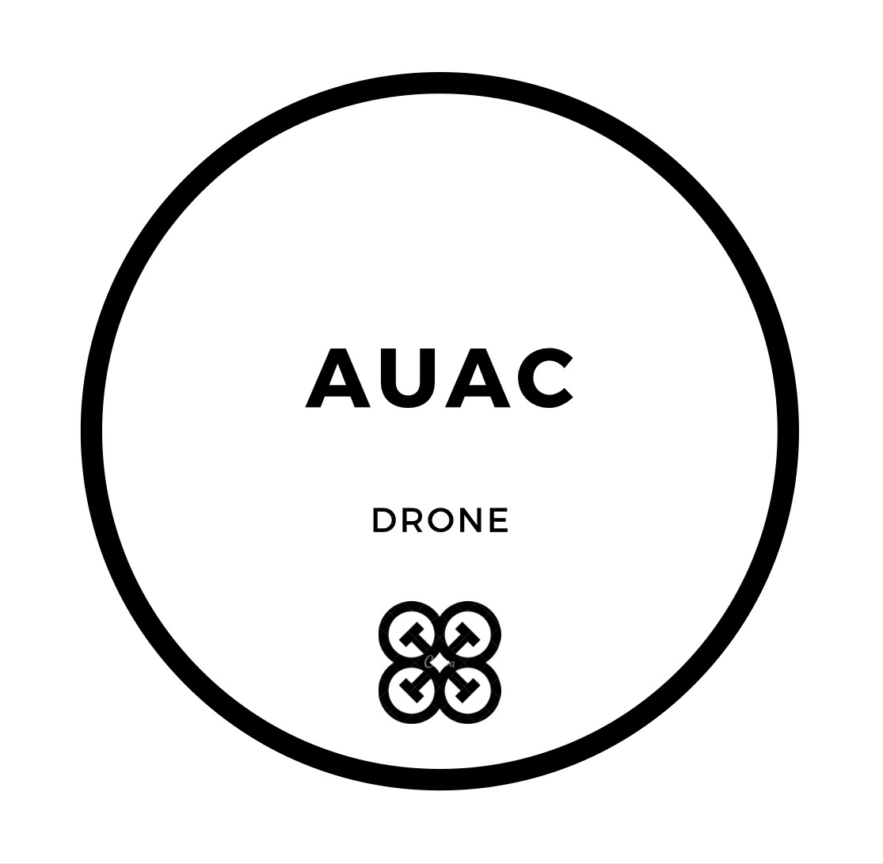

**Contents:**

1. **Core Flight Framework Introduction**

* **Firmware Layers**
* *CFF Layer*
* *Specialized Application Layer*
* **Ports**
* *Client Port*
* *Driver Port*

1. **Core Systems**

* **Tier 1**
* *Drivers*
* **Tier 2**
* *Vision System*
* *Navigation - Control System*
* *Telemetry System*
* *Communication System*
* *System Management*

Core Flight Framework

Vision/ML System

Port

**SPECIALIZED APPLICATION LAYER**

Port

v

GNC System

Port

Port

D

Port

Port

Tier 2

Tier 1

Port

Port

Port

Comm

System

Telemetry System

**SENSOR DRIVERS**

**AUAC FIRMWARE LAYERS**

**Firmware Layers**

CFF Layer

The Core Flight Framework (CFF) layer consists of two tiers. (Tier 1 and 2). These tiers contains different submodules and systems which can be accessed through ports. The CFF layer abstracts lower level routines and drivers from the specialized application layer